Lab: Docker Compose
Lab for the "Containers and Clouds" course @ SoftUni

In the exercises below we will learn how to work with Docker images, Dockerfiles, volumes, networks, Docker Compose, etc. to run multi-container apps in Docker.

MyWebsite App: Building a Custom Image

Step 1: Create a Dockerfile
Our first task is to create a Dockerfile for a Vue.js app, which will allow us to run it in a Docker container.
First, we have to go to the root folder of the Vue.js app that we created and ran in our previous session.
Our next step is creating a Dockerfile in this directory. The Dockerfile contains instructions on how an image for the app should be created. As we know, Dockerfiles are just text files, so we can create our own and open it with a text editor of our choice. Note that the name of the file should be "Dockerfile" without any extensions.
The content should be as shown below:
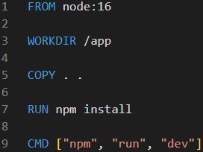
Each Dokerfile starts with "FROM", so we start creating an image, based on the existing image node:16.
After that, we will set the "app" folder as the current working directory and we'll copy all of the project files and folders to it. This will add a layer.
Then, we run the npm install command in order to install the necessary dependencies, so that our app can run. This will form another layer, too.
Finally, we execute the npm run dev commands, in order to run the scripts that defined inside our app's package.json file.

Step 2: Build and Publish the Image to Docker Hub

Build the Image
We can now build a custom image with this Dockerfile. Open a CLI, for example Powershell, and fulfill the following steps to do it:
- Navigate to the MyWebsite directory
- Use the docker image build command to build the image
- Set the local directory as the working directory
- With the -f option, set the path to the Dockerfile
- With the -t option, set the name of the image in format {your_docker_hub_username}/{app_name}, as we will later add our image to Docker Hub
The whole command should look like this:
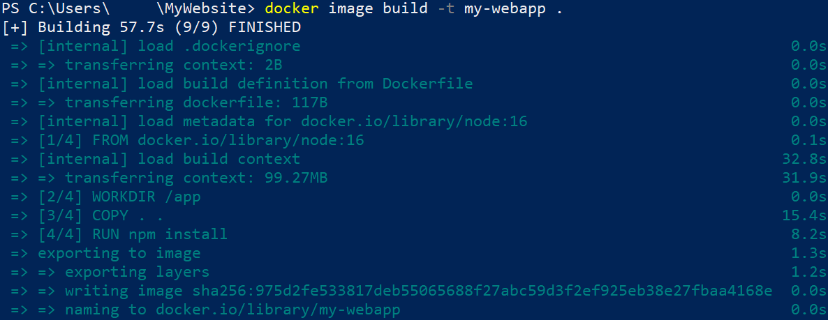
Note that we can examine how the instructions from the Dockerfile are executed to build the image.
We can check the ready image with the docker images command.

Publish the image
Now let's see how to push our custom image to Docker Hub. Note that this is not needed for running a container with that image – you can have the image only locally and still use it. However, it is good to know how to push images.
To push our image to Docker Hub, we should first log-in to Docker Hub with the command below. If this is the first time you log in, you should enter your credentials. Make sure that login is successful:
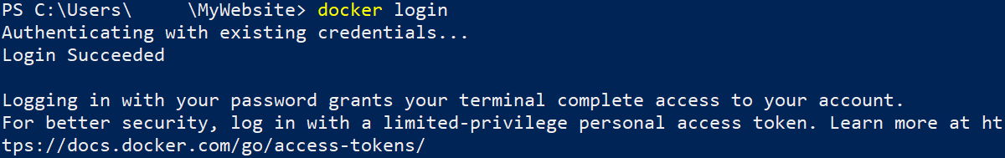
Now you should only push the image:
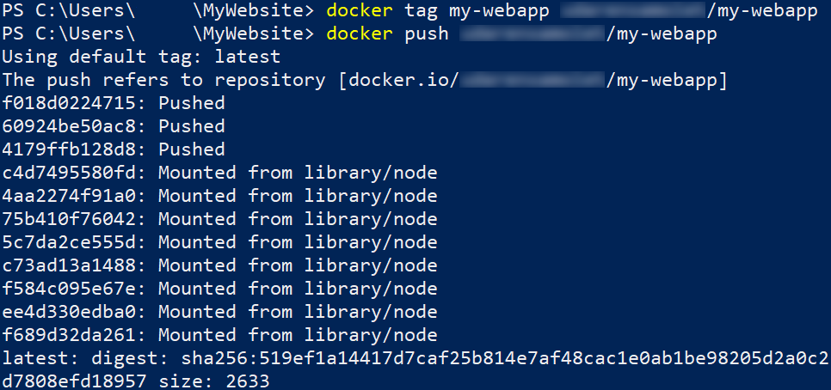
And it now is available at Docker Hub as a public image:
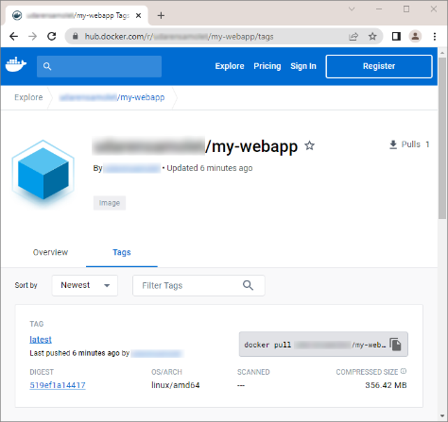

Run the Image as a Container
Finally, let's run the newly-created image as a container on the right port, using the command below:
Open your web browser and go to 127.0.0.1:8080. You should be able to see the running Vue.js app:
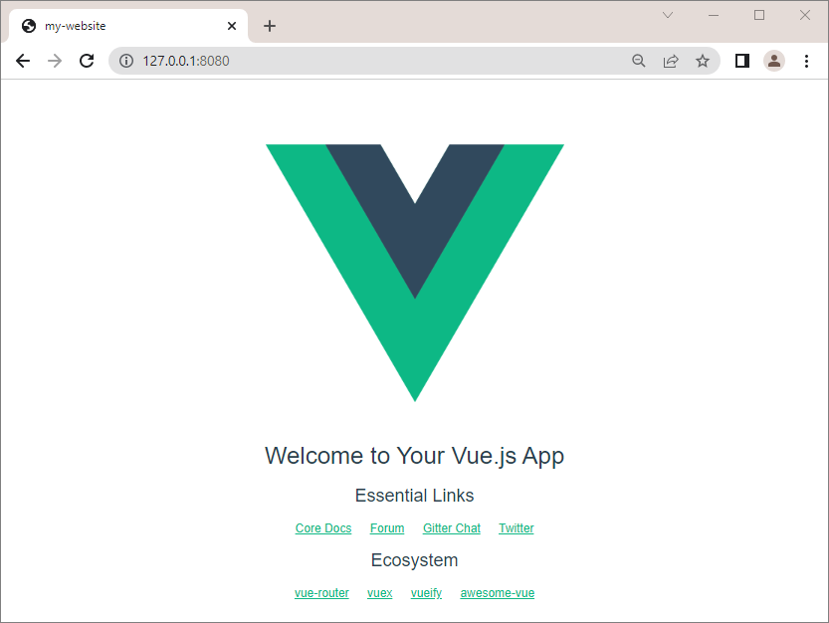

WordPress App with MySQL Database: Connecting Containers in a Network
In this exercise, our task is to set up and run a WordPress container in Docker with a MySQL database by connecting them in a network.

Step 1: Create a Network
First, we have to create a network. Open a CLI and first create a new folder, which will contain the files for our app. Then, create a new network with the docker network create {network_name} command.

Step 2: Add MySQL Container to Network
Our next step is adding the MySQL container to the network that we just created.
The commands from the resources are the following:
- docker run -dit → runs the image detached and in interactive mode;
- --name wordpress_db → names the container wordpress_db;
- -e MYSQL_ROOT_PASSWORD=pass → sets the password for the root MySQL user;
- -e MYSQL_DATABASE=wordpressdb → sets the name of the MySQL database that we'll use for the WordPress installation;
- -e MYSQL_USER=wordpress → sets the MySQL user that we'll use for the WordPress installation;
- -e MYSQL_PASSWORD=wordpress → sets the password for that user;
- --expose 3306 → sets the port of the container;
- --expose 33060 → sets the SSL port of the container;
- --network my_network → sets the network that we want to attach our container to;
- -v ${PWD}/data:/var/lib/mysql → maps the directory on our local machine to the directory of the container, so that we can store data outside of it;
- mysql → the name of the image.
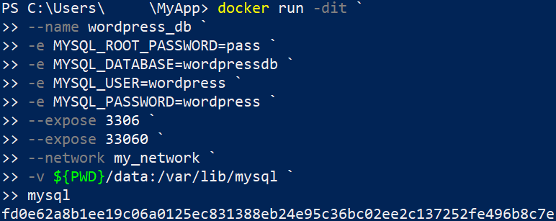

Step 3: Inspect Network
Now let's inspect our network in order to check if our wordpress_db container is attached to it:
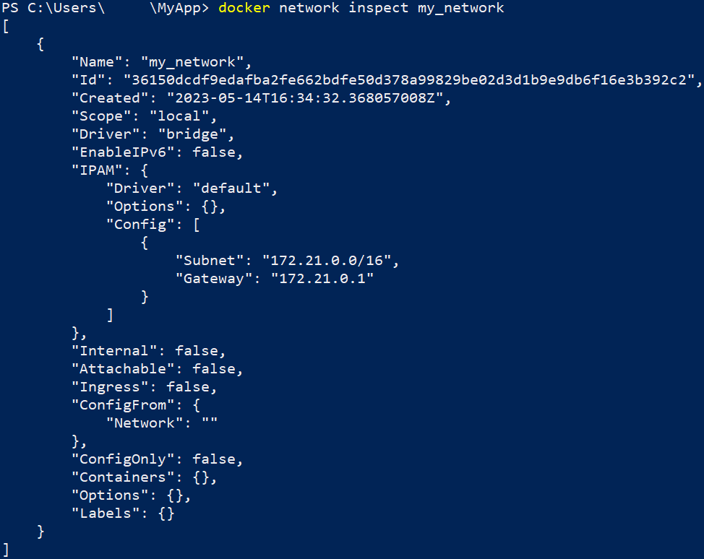
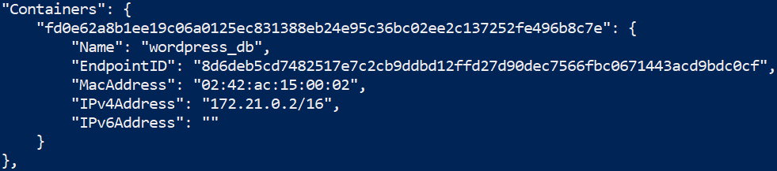

Step 4: Add WordPress Container to Network
Our next step is adding the WordPress to our network. You can do it with the following command:
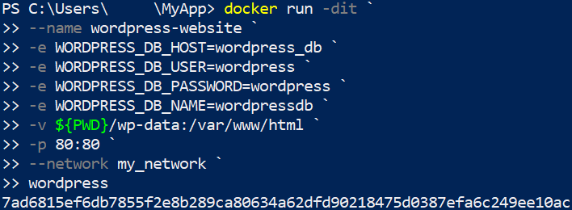
- -e WORDPRESS_DB_HOST=wordpress_db → sets the WordPress database host, which matches the name of our MySQL container that we set up in Step 2;
- -e WORDPRESS_DB_USER=wordpress → sets the WordPress user that we previously set up;
- -e WORDPRESS_DB_PASSWORD=wordpress → sets the password for the user;
- -e WORDPRESS_DB_NAME=wordpressdb → sets the name of the WordPress database, that we created in Step 2.

Step 5: Inspect Network
Now, if we execute the command for inspecting our network, we should see that the two containers are attached to it:
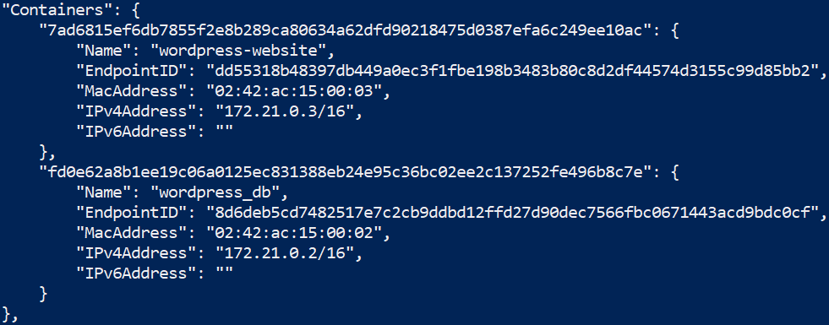

Step 6: Run the App
You can access the WordPress site on http://localhost:80 and you will see the WordPress setup page:

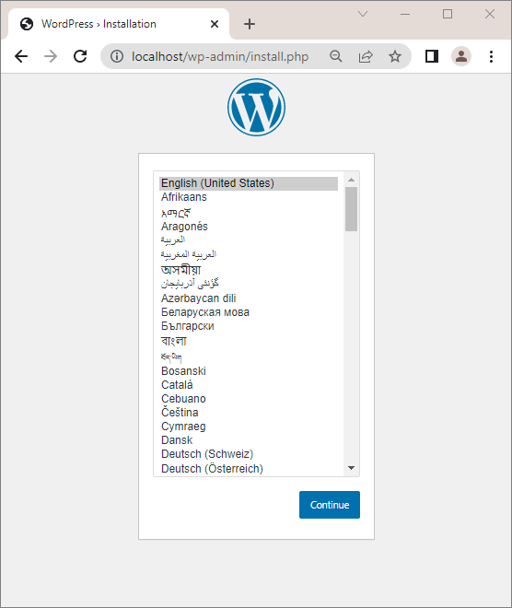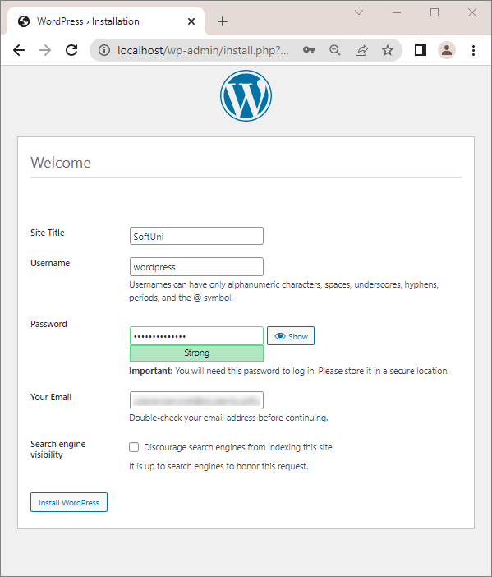
When you check Docker Desktop, you should be able to see the two containers combined in a single network:
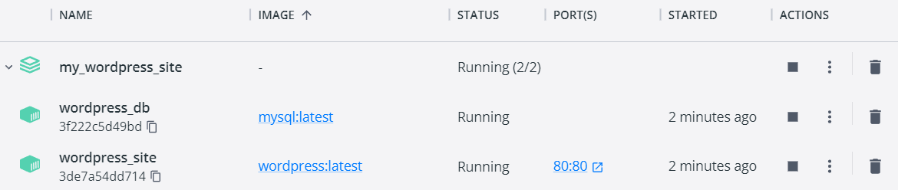

WordPress App with MySQL Database: Docker Compose YAML file
Our next task is, using Docker Composer, to create a docker-compose.yaml file with instructions for creating the MySQL and WordPress containers from the previous task, together in a single network, called my_network.

Step 1: Create a Network
Using the docker network create, create a new network, called my_network.

Step 2: Create the docker-compose.yml file
First, we have to create a docker-compose.yml file in the folder of our app. The docker file should look like this:
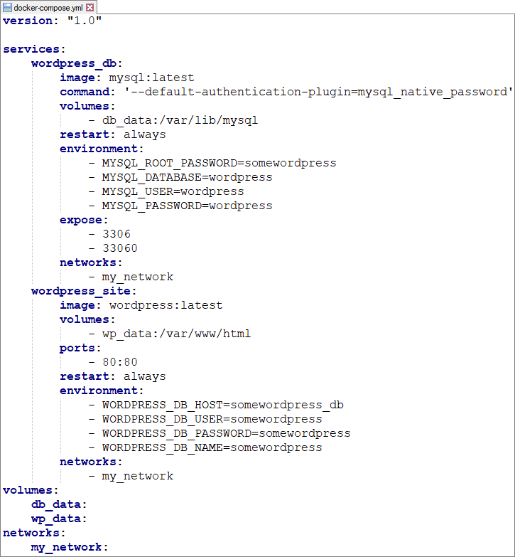

Step 3: Build and Run the Multi-Container App
Next step is building and running our multi-container app. First, build all of the images with the docker-compose build command:
Then, run the containers with the docker-compose up or docker-compose up -d command.
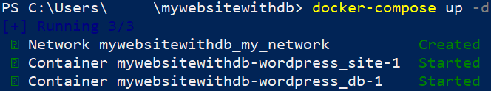

Step 4: Run the App
You can access the WordPress site on http://localhost:80 and you will see the WordPress setup page.

You should be able to configure and create your website, following the guide:

